Land Title Searching in Vancouver
Research Handbook
Summer 2014-2015

Land Title & Government Records Cluster
Landscapes of Injustice Project
University of Victoria

Prepared collaboratively by
Sarah Catterall, Ariel Merriam, Rebeca Salas, and Rebecca Wilmott

Under the supervision of
Jordan Stanger-Ross, University of Victoria

Note: This is a document for practical use in the field, prepared by field researchers. It has not been proofread or copyedited as a research output.

Landscapes of Injustice Information

In the Spring of 2014, Landscapes of Injustice received a federal SSHRC grant of 2.5 million dollars, funding a 7 year research project into the dispossession of property owned by Japanese Canadian citizens in the Second World War. In the first 4 years of research, this multi-institutional project will host a number of research
clusters, including the Land Title Cluster. The Land Title Cluster’s objective is to collect land title deeds pertaining to designated sample areas in Vancouver (the area formerly known as Japantown), Steveston, Saltspring Island, and Maple Ridge, all of British Columbia. Working with the Land Title Offices in New Westminster BC and Victoria BC, the cluster traces the associated property lots back in time, beginning with the most recent generation as it exists on microfilm (usually around the 1980s) and working back to deeds issued in the 1910s (or the last deed available on microfilm). Among many other things, the cluster is tracking patterns of sale, ownership, the value of each sale; this data will eventually answer questions like “Who benefited from the forced sale of land owned by Japanese Canadians”? Land Title Cluster research associates will be entering specific information from the documents into a working database. It is expected that land title research will continue through the summer of 2016.

The purpose of this handbook is to aid Land Title Cluster research associates in the process of doing land title searches and creating title entries in the Landscapes of Injustice Properties Database. It is formatted with three categories:
- Land Title Cluster Preparation: This section discusses important preparatory administrative tasks, such as consulting with the Cluster chair, gathering maps, creating spreadsheets, working with Zotero etc.
- Land Title Searches: This section will give a general “how-to” guide on conducting a Land Title search. While detailed information, such as examples dealing with a particular property lot, will be specific to the purview of the project, this section explains how title searches are conducted in general by land title agents.
- Creating a Title Entry: This section will discuss how to take the information that was collected during a title search (such as a land title deed) and explain how to enter this information into the Landscapes of Injustice Properties Database. This section includes a Protocol document which contains important formatting details
Note: This manual was created in Summer 2014 and updated in Summer 2015 at the New Westminster Land Title Office. It is expected that future research associates will continue updating and editing this handbook as necessary.

Land Title Cluster Preparation

Step 1: Selecting Properties
- Consult with the Cluster Chair regarding which properties you will research during your research period. He or she will assign a particular sample area, from the four listed above, on which research associates will conduct their work. The cluster chair will also be able to set expectations regarding number of titles to be entered, completion dates, and rates of accuracy.
Tip: Throughout the course of the research period, your cluster chair will likely require weekly meetings. Use these as opportunities to discuss findings and challenges. If you are working at the New Westminster office, you will most likely be working remotely from your supervisor. These meetings are essential to communicate the progress and challenges that your cluster chair cannot experience first-hand.
- Ideally, maps will be used in the process of selecting research sample areas. These visual representations are very important in:
  - Denoting the physical boundaries of your research sample area (eg. Vancouver research included properties East of Main St, West of Campbell Ave, and North of Hastings St.)
  - Communicating important legal description* information, such as a Plan Number* that resulted in a merging of two lots.
  - Civic addresses for each lot.
*Tip: See under “Land Title Searches” for definitions.
- It is also very beneficial if the Land Title Cluster can acquire several maps at different time intervals for the research sample area. Maps of different generations can show physical changes, such as how a subdivided Lot A on a map from 2000 used to be 3 individual lots on a map from 1913.
Tip: If it is possible, and only with permission from the associated Land Title Office, digitize any maps. Have a copy on your personal computer for consultation throughout the research period, and make a copy available on the Landscapes of Injustice research forum, Zotero (which will be discussed below).
- Once your Cluster Chair has determined the sample area for your research period, and you have consulted (and digitized) corresponding maps, you are ready for the next step.

Step 2: Understanding terminology
- As part of your work, you will need to become familiar with terminology commonly used in this field of research. The following is a list of a few common terms you will likely encounter (bear in mind that this list is not comprehensive).
- Legal Description: this is the most important. A legal description is essentially “a method of describing land.” A legal description uses a series of designated numbers to explain where a piece of property lies, when its current boundaries were ratified, and how its current boundaries were formed. As part of your training, you will learn how to read legal descriptions and create them from the information you find on pertinent maps. The following information is included:
  - District Lot or Section: This number denotes a broader area of land and is usually based on the original designation of land. In many cases particularly in urban areas it holds historical value only.
  - Plan: This number indicates the most recent change or implementation of a land entity’s boundaries. A Plan number is applied to a Block. A plan that changes the boundaries of an individual lot is referred to as an Explanatory Plan. When you are working with the legal description of a Lot, you must use the Plan number that is specific to that Lot. If there is not an individual Explanatory Plan indicated for that Lot, then the Plan number for that Lot is the Plan number for the Block. You will be shown how to identify these differences in your training.
  - Block: This number denotes a compilation of lots.
  - Subdivision: This is usually designated as a letter (A,B,C etc) . It indicates where Lots have either been merged to create one bigger Lot, or divided to create multiple smaller lots. This kind of designation is rare in the Victoria LTO.
  - Lot: This number denotes the standard individual piece of property.
  - Parcel: A description for any piece of land – a lot or a grouping of lots can be a parcel. This was rarely encountered in the Summer 2014 research period, and was always explicitly stated on the title document.
- Title Document: This is the final document that designates a transfer of land. It will indicate the owner, legal description, next title number, and the ratification date. This document is used in conjunction with a corresponding “Transfer” document, but the Title document is always the final authority.
- Transfer Document: This document is usually created in conjunction with a Title Document (it will be designated by the same title number). It is usually much longer and contains full details of the transaction, including the Seller, Lawyer, value of the land etc. Most of the information required for the database will be found on this document. However, if there is any discrepancy between the Transfer and Title documents, the Title document will be taken as correct.
- Rights to Purchase: In some cases, a sale of land will not automatically produce a new land title upon registration in the LTO. Instead it will be noted as a “charge” registered on the land title. The charge will show “RP” or “Right to Purchase”. This was a common means of land sale in the past and basically allowed the purchaser to pay the vendor via a series of installments. Once the last installment was paid, the vendor was obligated to transfer the land to the purchaser at which time a new land title was created. When the new title is created in this way, the RP will be “merged” (ie. Into the new title). Though not allowed any longer, it was not uncommon for RPs to be subsequently sold to a new owner at which time the title would be noted with a new charge for a “Sub Right to Purchase”. For the purposes of tracing the chain of title, Rights to Purchase should be noted as a link in the title chain.

Step 3: Personal Methods of Tracking and Recording Data
- The very first thing you must do is create a master spreadsheet for every single piece of property you are expected to search during your research period. It is then recommended that you divide the master spreadsheet into individual spreadsheets for each Block that is to be research, and assign specific Blocks to specific research associates. Once this has been done, each research associate will now be responsible for working on their assigned blocks.
- A spreadsheet is essential for tracking and recording your progress on the Block you are currently researching. Without a personal method of recording this kind of information, you will not know what you have completed and what still needs to be researched.
- Your spreadsheets are not just for your own use; they will be used by research associates from other clusters.
- There are spreadsheets on Zotero (expanded below) from the Summer 2014 research period. For the sake of continuity, it is suggested that you model your spreadsheet after either of these formats. Regardless, your spreadsheet must contain the following
  - An abbreviated legal description for every single piece of property that you are expected to search during your research period (An abbreviated legal description should include District Lot #, Block #, Plan # and Lot #.). This information will come from the maps that are pertinent to your research sample area. You will be shown how to read these maps and identify legal description information as part of your training.
  - A column to enter the current set of titles you are working on. Above everything else, you MUST track your title numbers. You should also have a “trace” column, where you enter the number of the NEXT title that you will have to search for that Lot. That number will appear on your current Title document
  - A date column. This indicates when you entered a block into the database, and is important for things like data-checking. An alternative to a date column is that you create a new spreadsheet tab for every day you work (the new tabs would all be compiled under that Block’s spreadsheet). On the image below, the bottom left corner shows three “Sheet” tabs. This is how you would create a new spreadsheet per day, while remaining in the same Block spreadsheet. This is also an excellent format to use for your own spreadsheets.
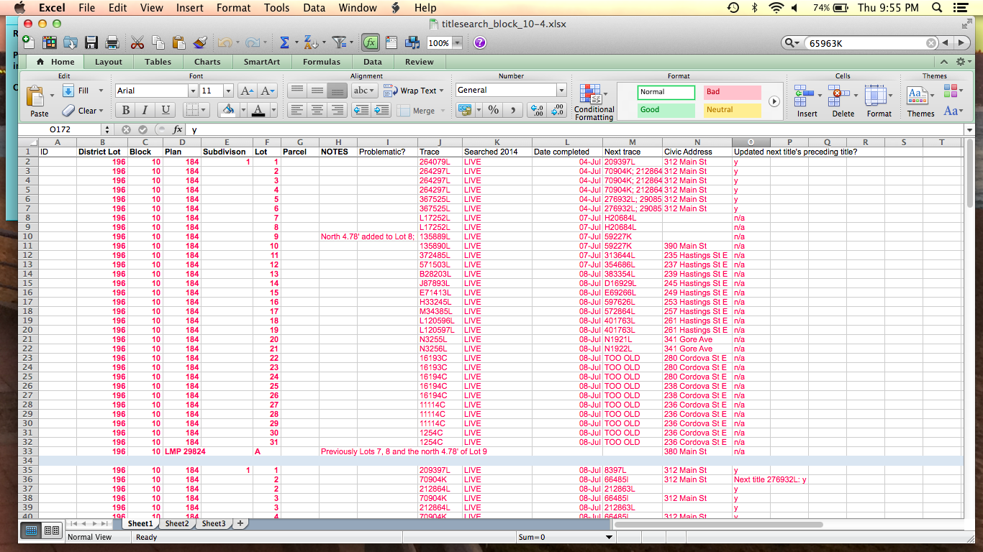

Step 4: Understanding Zotero
- Zotero.org is a website application where researchers are able to compile and share their findings and knowledge. Landscapes of Injustice uses this application to share work between the various research clusters. Once a Block is complete, the Land Title cluster uploads their corresponding spreadsheet to Zotero. This both shows progress and allows other researchers to interact with your research, and tailor their own work/progress as required.
- Information about accessing Zotero and uploading documents is included in “Protocols for Archival Research” created July 2, 2014. The document is included at the end of this guide.

Step 5: Knowing the Land Title Office
- This does not mean knowing where things are, although that will come with time. Working in the Land Title Cluster requires that you learn an entire field of research in a matter of a few days. Therefore, it is to your absolute benefit that you meet and connect with other staff working in the Land Title Office. Your most valuable point of contact will be the title agents. They are the people who will be working alongside you at the microfilm machines. They are a wealth of knowledge and can probably help you with almost every question you will have during your research.
Tip: While the title agents are very helpful, remember that they are also very busy and that their time is in high demand.

Land Title Searches

Step 1: Finding your Title Numbers.
- Once you have established the sample area you will be researching, have selected the first Block you will be researching, and have created a spreadsheet to track your progress, you are ready to find your first round of title numbers.
- Firstly, you will need to create a list of the most recent cancelled title number for every single Lot in the Block you are working on. Once you have this list, you will be able to work backwards through the transaction history of a Lot.
- Take your Block spreadsheet that has the abbreviated legal descriptions for every Lot, and make sure you have a Title column ready to go.
- Ask a title agent to show you where to find the books or sources of information that hold the most recent cancelled title numbers for each block. In the New Westminster Land Title office, this information is found in the Plan Index Books. The Vancouver sample area cancelled titles are located in
Row 1 Absolute Fees - Vancouver
Plan Index Books - Vancouver.
- Each book can be found in an archival box, labelled as follows:
  - Vancouver Property Index: Subdivided Land
  - VAP------ - VAP-------
- In the New Westminster Office, the VAP------ numbers are the Plan numbers designated to the Vancouver area, which you will already have in your abbreviated legal descriptions. Using the relevant plan number, locate the box that will contain the Index Book containing your plan. For example, if your plan number is 196, look for the following reference label:
Vancouver Property Index: Subdivided Land
VAP00196 - VAP00228.
- Open the folder, and flip through until your find your Plan number (eg. 196) – they are ordered chronologically.
  - The Plan number will be in the uppermost right hand corner of each page.
  - To the left of that number will be your Block number (eg. 53).
  - Each page contains the Lot numbers for each Block running down the right hand side, with title numbers located next to each one.
  - You must wear archival gloves when handling these books.
- Once you have found the page with both your Plan and Block number (eg. Plan 196, Block 53), locate your first Lot number (eg. Lot 1). Beginning at the far right hand side of the row of title numbers, work your way back to the left and STOP when you come across a number with a line through it and the letters “CT” written above it. This is your first cancelled title number. Proceed on to the next Lot and do this for all of the Lots within the Block and Plan you are examining to find all of their most recent cancelled title numbers.
- As you find your first cancelled title number, record it on your spreadsheet. You will only need to go through this process at the beginning of researching a new Block.

Notes on Plan Format and Location
- If you are required to pull a plan, there are a few locations for each plan type:
  - Plans with no prefix are filed under “VAP” in Vault 1.
  - Plans with letter prefixes (eg: LMP) are filed under the corresponding prefix in Vault 1.
  - Reference and Explanatory Plans are filed in shelved boxes around the perimeter of Vault 1.
  - Key Plans (Sectional Survey Maps) give legal and detailed municipal descriptions of properties of specific District Lots. They are filed in (and on top of) large cabinets near the main entrance of Vault 2.
- The LTSA is in the process of conserving and restoring older plans. Currently, any plan under VAP 1000 is in “oversized folders” or waiting to be restored. Please refer to the binder near the Key Plans, or ask a Conservator when locating these plans.

Notes on Title Number Format
- There are a few common formats for a title number (as pertains to the New Westminster Land Title Office).
  - A123456L – the most recent generation of title numbers often have a prefix as well as a letter suffix
  - 612345L – the next generation goes as high as the mid 600 000’s with a letter suffix. The numbers then decrease as you go back in time (eg. 512345L, 32145L, 912L etc).
  - 12345K,E, and I – at the New Westminster Land Title Office, the older generations of title numbers end in a K, E, or I.
- However, when you are searching through the Plan books for your first cancelled title number, you may not find one that exactly fits the above formats.
  - If your most recent cancelled title number begins with the prefix GD (or GB or GC), skip this one. This title number is so recent that it has been digitized and will only be available online, not in the microfilm. Continue scanning back to the right until you find the next cancelled title.
  - Sometimes, the most recent cancelled title will NOT have the designation “CT” indicated. Look for a 6-digit title number with a 4 digit folio number written above it, with a line drawn through it. This is most likely also a cancelled title. Begin with this one, if this is the most recent viable cancelled title number listed.
  - Eventually it will be fairly clear which are NOT CT numbers - anything that ends with an M, for instance. In the New Westminster Office, if you come across the suffixes A, C, O etc - this likely means the titles are too old and will not be found on a microfilm reel. Other land title offices will likely have different designations. Don’t worry about these, unless they are ONLY available title. Ask a title agent to show you how to find a title in the books.
- Letter Suffixes: The letter suffixes on a title number are specific BOTH to the area of land that the property is within, and the Land Title Office.
  - New Westminster Office: the suffixes are L,K,E, & I.
  - Victoria Office: the suffixes are I, N, & W.
  - Prince George Office: the suffixies are A, F, & M.
  - Prince Rupert Office: the suffix is I.

Step 2. Locating the microfilm roll with your title

- Once you have compiled your list of the most recent cancelled titles, you need to find the microfilm reels that will contain your title and transfer documents. Part of your training and orientation should include a tour as to where the relevant microfilm reels are kept.
Tip: During the Summer 2014 session, the New Westminster Land Title Office was under construction. As such, the location of the microfilm reel cabinets changed a couple of times without warning. This is a good example of the importance of building relationships with other title agents!
- You will need to get both the title document reel and the transfer document reel that correspond to your title number. So if you are pulling reels for 5 title numbers, you will probably have 10 reels.
- The filing system for the title numbers is designated by number, letter, and prefix. This system will likely be different for each Land Title Office. This will be part of your orientation.
  - In the New Westminster Office, the title numbers are filed chronologically WITHIN their prefix or suffix groups.
    - Prefixed title numbers are first: A-------L to P-------L
    - “L” suffixed numbers are second: 1L – 650 000L (approx.)
    - K, I, and E suffixed numbers are third.
- Transfers can be found in many places, depending on their title number suffix or prefix. Part of your training and orientation will include a tour as to where these reels are located.
  - In the New Westminster Office, the transfer document for a title number with a letter suffix but no prefix would be located in “__FEES” cabinet with the corresponding suffix letter. The label would be formatted as such:
    - L Fees; 1L – 10 000L
    - K Fees; 11 999K – 32999K
  - In the New Westminster Office, the transfer document for a title number with a suffix and a prefix is filed according to the prefix. It would be located in “__SERIES” cabinet with the corresponding prefix letter. The label would be formatted as such:
    - P Series: P12345L – P32456L
    - A Series: A23456L – A54321L
- Once you have both the title document reels and transfer documents reels you need, you can begin work on the microfilm machines.

Notes on Missing Cancelled Title Documents:
- You may scroll through your microfilm reel and discover that your title document is not there. Sometimes, a title will be added to a reel after it’s creation and it will be added on either to the very beginning or very end of the reel. Look at the very first and very last titles on your reel in case the missing title is there. If it is not, there are a few ways of locating a missing title.
  - Find out if your Land Title Office has a “Missing Documents” drawer. In the New Westminster office, there is a drawer containing highlighted reels that cover all missing cancelled titles that have an L suffix and no letter prefix. Those reels cover missing titles. They ALSO cover any title with a number greater than 616498L.
  - Ask if there are methods of designating a reel that may contain missing documents. In the New Westminster Office, there are a few highlighted reels for the I, E, and K suffixes missing titles. They are all in the same drawer where you will find the other I, E, K reels.
  - Ask if there is a system of notation about missing titles. In the New Westminster Office, there are binders that contain an explanation as to which titles are missing and where they MAY be located. Be warned - this binder is far from comprehensive and may not contain information about your missing title. The binder is labeled Vancouver Cancelled/Converted Titles.
  - If you still can’t find the title, it is considered missing. Use as much information from the transfer document as possible to create an entry in the database and indicate that the document is missing in Title entry Notes Field in the database. For an example, see 13753E in the database
Tip: There are no cancelled title documents for E suffix titles with a number ranging before 34000. These have to be entered from their transfer documents alone.

Creating a Title Entry

The Landscapes of Injustice Properties Database was created for the specific purpose of recording the data collected from title and transfer documents that correspond with lots in the research area of interests. Part of your training and orientation will include spending time exploring the database and learning how it functions.

Step 1: Inputting Data
- While this database has been used for older research, the most updated version ONLY includes title entries from the Summer 2014 research period. Therefore, every title entry you create will be a new entry
- In the database, there will be a series of tabbed headings, beginning with “Instructions”, “Tools”, “Titles” etc and going on until “Institution Types”
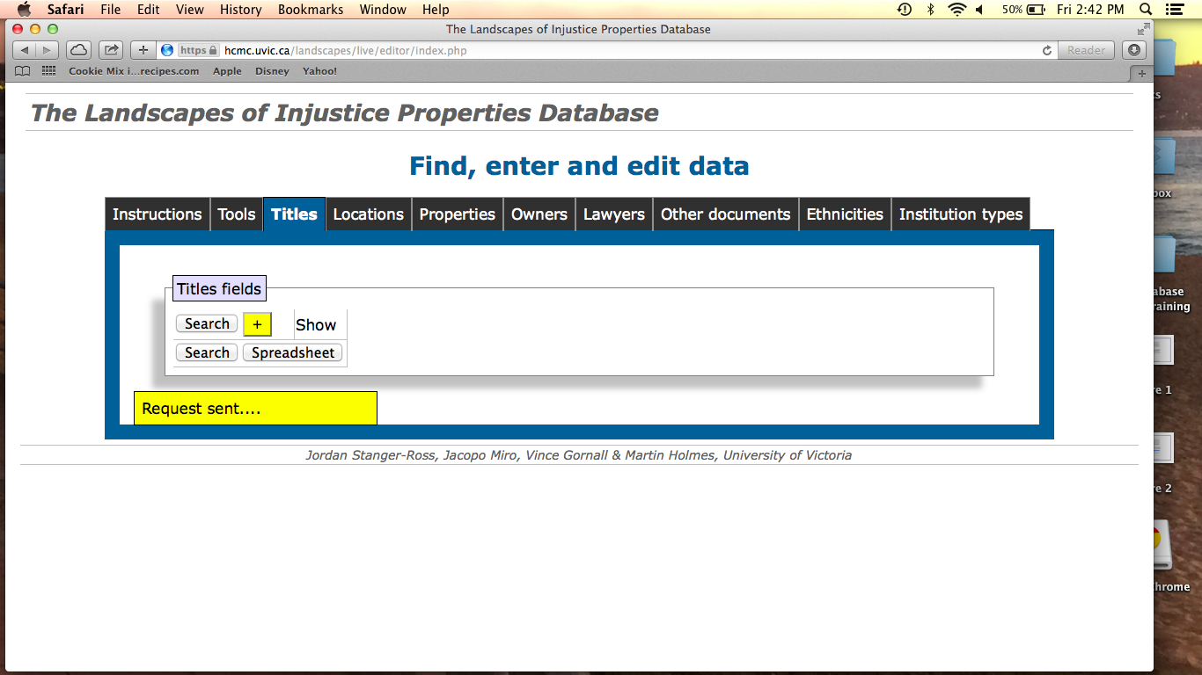

- Select the “Titles” tab. Once you are in the Title category, you will have to select “Search”. A new table will pop up below with “ID”, “Title Code”, “Traces” etc and it will show a list of previously entered titles.
- At the far right-hand top corner of this table will be small box containing an * symbol, next to the word “Action”. Click on this to start a new entry.

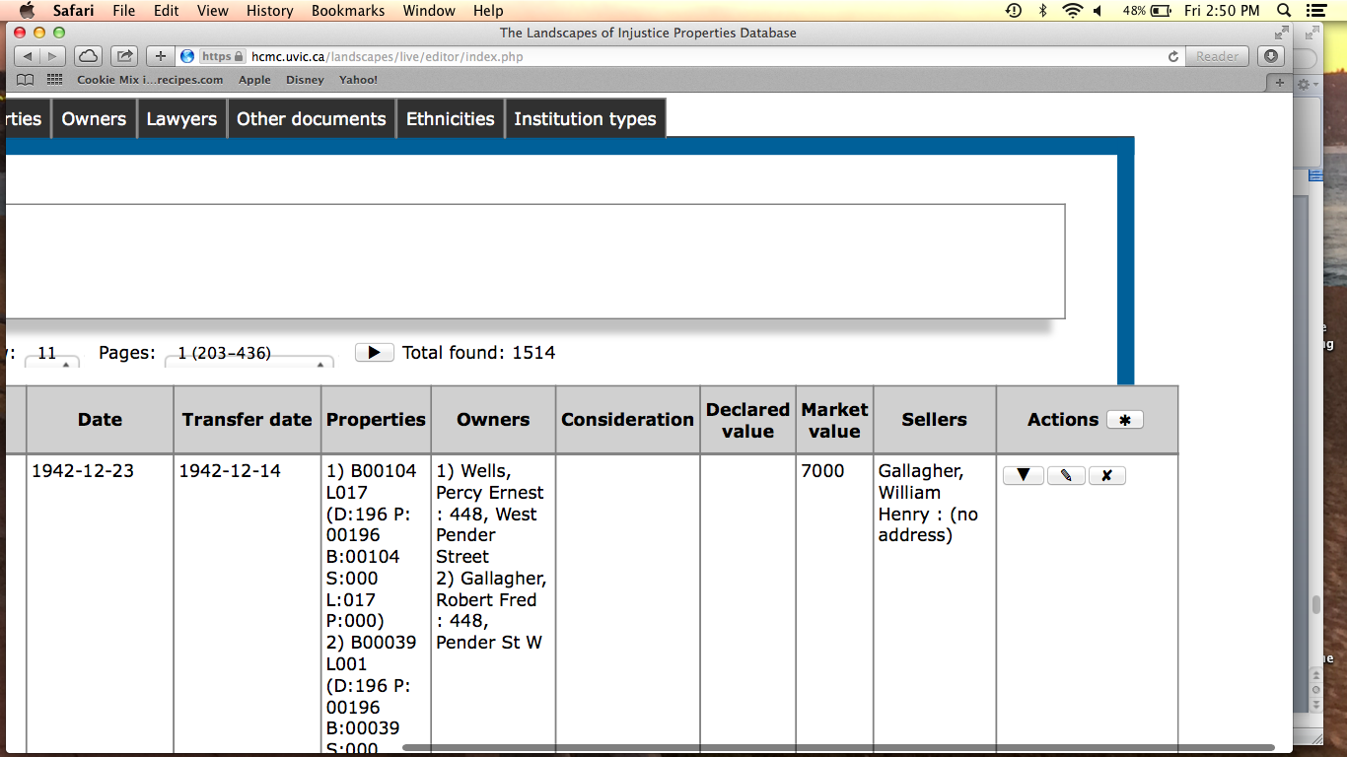

- There will be a series of hard and soft fields for you to either directly enter information into, or link from other information already existing in the database
- Soft field information, such as Owners, Lawyers, and Properties, have to be entered as hard field information in their corresponding categories. You will see these tabbed headings in the set beginning with “Tools”, “Titles” etc and going on until “Institution Types.”
- In the same way as creating a Title entry, you will go into the relevant heading (such as Owners), select “Search” and then select the box with the *to generate a new entry.
- PLEASE REFER TO THE TITLE ENTRY PROTOCOL 2014 for important detailed information about creating Title entries, Owner entries, Properties and other information about entering data into the database.

PROTOCOL FOR ENTERING TITLE INFORMATION
The following information is very technical and specific. Part of the research process includes regular intervals of data-checking, to ensure that, as a cluster, we are being consistent and precise in our recording of information. As this is a multi-year project, uniformity will enable a smoother transition between researchers from year to year, as well as making the process of analysis easier. While this may seem like a lot of detail, you will quickly have this memorized.
This protocol document has been created to mirror a title entry. You should be able to follow along

Title Code
No spaces before suffix or prefix: R91233L
No dashes indicating Lot number: these are from pre-2014 Old Data and must be removed and the title entry must reflect that the title covers multiple lots. Example: 334495L-13 is NOT correct. 334495L is correct
While we are typically trying to enter everything as it is entered in the document, do not follow the formatting of previous generations who wrote title numbers on documents like 458101-L or 1584 “C”. In these cases, enter 458101L or 1584C.

Traces
Include list of possible preceding titles.
Example: “33385E; 93876E”
If no trace available, write “NO TRACE” in trace field.
Can also include “TOO OLD. SEE BOOKS.”
Example: “13024C; TOO OLD. SEE BOOKS,” or just: “TOO OLD. SEE BOOKS.”
Occasionally, Traces can include the current title number. This happens only when a transfer folio contains multiple transfers that cover the same property over a long period of time – usually into the 19th century. This most often happens in “E” suffix transfers. In this case, the Trace field for title 33385E would look like: “33385E; TOO OLD. SEE BOOKS.”

Dates
1. Date (in Title field, YYYY-MM-DD)
We have been pulling from the confirmation date of the title document, which is located toward the bottom of the Title document. This is usually prefaced by “Signed and sealed by me, ________, on [date]” or “I have hereunto set my hand…”. This is not the date of application received, which is usually higher up on the title document.

If there is no Title date, leave the field blank and include an explanation in the Notes field.

2. Transfer date (in transfer field, YYYY-MM-DD)
We have taken the confirmation date of the transfer document as well. In some generations of paperwork, it is denoted “Executed this [date].”
Previous to July 2014, we were taking different dates as the transfer date. Some entries may use the “This INDENTURE Made on ________” date rather than the “executed/signed” date of the transfer. We have coordinated to take the executed/signed date of the transfer, and where that is unavailable or illegible, then the INDENTURE date.

Properties
In the Property Notes field, include explanatory/reference plan numbers if applicable. These usually only occur for properties that have been amended or altered somehow (i.e. made smaller, or joined with other lots).

If there are many lots included on the title and transfer, only some of which are part of the current sample group, add them all into the title entry.

If the transfer and title disagree on which lots are included, rely on the title document to enter the properties of the title entry. Include in the notes field a description of any discrepancy between them.
Example: Transfer document says this is "The West 0.5 feet of Lot 6, Block 53, D.L. 196, Gp. 1, N.W.D., Plan 196." The transaction conveying the above description of land to Wong Ham results in the indefeasible title of Parcel A (Ex Plan 4575), Lots 5 & 6 of Block 53, D.L. 196. --- (Title No. 344028L).

Owners, Sellers and Lawyers
Owners and Sellers are both entered in the “Owners” category. For the sake of caution, enter a new owner(/Lawyer) if the name is the same but the address/occupation is different or if the information is unavailable.
Special case: People as Executors of wills often transfer property to themselves, to register as non-Executors. This is obviously a transfer to/from the same person, but the address is listed for the person as non-Executor but usually not for the person as Executor. Because we can be sure this is the same person, we can include the address in the “person entry” and write “Executor of the estate of _______” in the Owner Notes field. Include the Deceased Filing number here if you know it. In the Title notes field, explain that this is a transfer from “John Smith as Executor” to “John Smith”.

Vesting Orders: Usually just the name of the person is available (no address listed on Vesting Orders), but also record the Vesting Order number in the Owner notes field and the Title notes field. If possible, also record the Police Registration Number in the Owner notes field.

Be careful when entering Owner addresses. If they are ℅ a law office, and their address is the same as the Lawyer entry, leave the address field blank, because we cannot be sure that they reside there. Note in the Owner notes field the address of the law office and their “care of” status. For institutions with an address that matches the Lawyer address, enter the Company address as it is written and include a note in the Owner notes field saying “Lawyer address and company address identical”.

If an Owner’s address has a PO BOX number, include that in the Street Number field. Eg. Street Number: Box 77 (include the ‘PO’ if the document contains it).

WHEN IN DOUBT, CREATE A NEW OWNER/SELLER/LAWYER ENTRY. Redundancies are easy to fix later.

Names
For Chinese-Canadian and Korean-Canadian names, there is some discrepancy over what should be taken as the last name. In some cases, names have obviously been Anglicized and the Surname appears last (eg. John Wong). In others, it is clear (due to multiple family members) that the Surname appears first in sequence. For the sake of uniformity, take the FIRST listed name as the Surname (for two or more non-Anglicized names). Enter the remaining names in the Forename field. For name spelling changes, make a new entry unless it is very clear that this is the same person (if you have an Also Known As document or if the name is irrefutably unique).

For illegible names, put the first initial. For almost legible names, putting a bracket around the questionable characters is recommended.
ex. John D. Bell (the middle name was illegible)
ex. Sydney Archibald Rober(t)s

Person Titles
Esquire - Add “, Esq.” to surname. Eg: Chan, Esq.
Princess - Add before forename. Eg. Princess Mary
Senior/Junior/The Younger – Add as suffix to surname. Eg: Smith (Junior), John

Occupation

For occupation changes, make a new person entry.

“And’ vs ‘&’: *Barristers and Solicitors: in Occupation, write out the ‘and’ if you have a Barrister and Solicitor. If “Barristers & Solicitors” is in the institution name, and typed out that way in the document, you can keep it that way as part of the institution name.
For women - include ‘Wife’, ‘Widow’, ‘Spinster’ etc as occupation - this may be depressing, but what can you do? Also enter it into the Owners Notes field, especially if they list the husband’s name
Eg: Wife of John Smith. Exception: If a woman has listed both her marital status and a separate occupation (eg. Wife of -----, Laundry Proprietor), include the occupation in the Occupation field and her marital status, including husband’s name, in the Owners Notes field.

Owner/Seller/Lawyer notes field
If an Owner is an executor/executrix of a will, include that information in the Owner Notes field.
If the address is illegible, write it into the Owner notes column along with your best guess.
If an owner is care of an address, person, or institution, record the care of status in the notes field.

Addresses
Street address
ex. Georgia St W
ex. Powell St E
ex. 41st Ave E

Civic abbreviations
Street = St
Avenue = Ave
Boulevard = Blvd
Drive = Dr
Highway = Hwy
Crescent = Cres
Court = Crt
Alley = Aly
Rural Road Number 3 = R. R. #3

City
ex. Vancouver
If multiple cities (rare), put an ampersand between them
ex. Victoria & Vancouver
ex. Victoria, Vancouver & New Westminster.

Province
ex. BC
ex. MB
If you have an American state, enter it in the province field like so:
ex. Washington, USA (include the country in the Province field, if any nation other than Canada)
If you have a country and no province/state, enter it in the province field:
ex. England

Postal Code
ex. V6B4N7 (do not put in any spaces).

Buildings:
Some owners will be listed at an apartment number.
ex. D-2152
41st Ave W
ex. 4133
Granville St

If we have a building name and no street address for the building, the apt number is entered in the Street Number field and the building name is entered in the Street Name field. The biggest example of this we have is the Custodian (506 Royal Bank Building). When the Street Name field is a building, this means that the “Street Number” is actually the suite/apt. number. This is a provisional measure for the purposes of data entry.
We would enter this as
Street Number: 506
Street Name: Royal Bank Building

For addresses that have an apartment number, building name and building address, enter as follows:
Street number: [apt#]-[bldg address#]
Street name: [street name of bldg address]
And then in the notes field, write out the full address.
Example: Albion Land Co. Limited
Street number: 410-739
Street name: Hastings St W
City: Vancouver
Province: BC
Notes:
410 Winch Building
739 Hastings St W
Vancouver
*Buildings: Spell out “Building” or “Bldg” based on what is on the actual document.

If an address has multiple apartment numbers, a building, a street number, and a street name, simply use the street number and name, and include the apartment and building information in the notes.
Eg: 411-14 Rogers Building
470 Granville St

PO Boxes - if there is not a separate Street Number, include the PO Box and number in the Street Number field. If there IS a separate Street Number, include it in the Owner Notes field.

If the street has a Rural Road number, include the full address including RR# in the Notes field of the Owner. Do NOT include RR# in the Address fields, UNLESS R. R. #x is the only street name given.
Example: Owner Notes field: 2359-5186 Cordova Bay Rd R. R. #4
Example: Street #: Derewenko Farm
Street name: R. R. #2

Lawyers
Check the transfer document for the lawyer information - most likely on the cover page. Check the Deed page as well (usually at the end of the transfer document), as there is often lawyer information in the bottom. If you have an Agent/Solicitor listed on the cover page, and a legal firm on the Deed page, compare the two addresses. The legal firm on the Deed likely will have a firm name (eg. Smith & Smith). If the two addresses match, blend them into ONE lawyer entry. Enter the Agent/Solicitor name information from the cover page in the Surname and Forename fields. Enter the firm name into the Institution field, as well as any occupations (eg. Barristers & Solicitors). In the Occupation field, enter the designation of the Agent/ Solicitor. Eg:
Surname: Gray
Forename: C. Boyd
Institution: H.M. Drost, Barrister and Solicitor
Occupation: Solicitor
Address.
If you have a law institution, enter it as an institution and ignore the occupation field if you do not have a specific individual (solicitor or agent) associated with it.
Example:
Institution name: Fraser & Blakney Barristers, Solicitors Etc
Occupation:

Care of (c/o) Protocol
If an owner is care of a person, address, or institution, record the address and care of status in the owner and title notes. Do not record an owner’s occupation as “care of”.
If a legal firm name (Institution Name) is prefaced by a ‘c/o’, do not include the ‘c/o’ in the database entry.
If a lawyer is care of an institution or person, record the address in the address fields and note the care of status and person in the lawyer notes. You may also note the status and information in the titles notes field if you feel it is important or telling to the transaction (eg: if the lawyer is care of the an institution noted as owner or seller, such as Walter Freth Edmonds as care of the Custodian of Enemy Property).
**Note: Sometimes the care of status is noted using a “%” symbol.

Values
Enter integers only. No $, no decimals. If your value has a decimal and cents value, round up/down as necessary. Enter the true value in the title notes field if you have had to round a value. If a market value is for ⅓ interest (or other), that should also be marked in the notes field.
You will most likely not have all three value fields (Consideration, Declared and Market) containing a value on a single transfer. A title entry should either contain Consideration and Declared OR Consideration and Market. The exception is, of course, if any value information is missing (i.e. there is no consideration value) - include any missing information in the notes field.
The consideration value indicates the actual amount of money exchanged in the transaction. The Market and Declared values are both the reflection of the fair market value of the property.
Tip: Declared and Market Value are the same. Declared Value appears on the most recent titles; Market Value appears on the older titles. However, there is a separate designation for each in the database. Even though the figures represent the same thing, enter “Declared” into the “Declared” field, and “Market” into the “Market” field.

Joint Tenants and Tenants in Common
Joint tenancy is joint ownership with right of survivorship (if one owner passes away, their interest with automatically pass to the surviving joint tenant(s)).
Tenants in common are joint owners without this right.
If the owners are joint tenants, link them into the joint tenants field.
If sellers are joint tenants, do not link sellers as joint tenants, but note their tenancy in the title notes.
If there are tenants in common, do not link them, but note their status in the title notes.

Ownership split
Enter information about the interest (undivided ½ interest, ¾ interest and so on). Do not put this in the Title Notes field.

What to include in Title Notes field
If there is no Title Document available, note this in the Title notes field.
If there is any usual information missing, explain what is missing. For example, each entry should have a Date, Transfer Date, Owner, Seller, and so on. If you do not have this information, include that. Joint tenants, Ownership Split, Corrections etc - this does not need to be mentioned as these fields are not expected for all titles.
Include “tenants in common” designation in Title Notes because it is not reflected in the Joint Tenants field.
Include information about transmission to Executors of Wills, Estates, etc., especially in cases where an owner is transferring to themselves.
If you have an Explanatory Plan number for a certain parcel/subdivision/amended lot, include it here.
If someone has deceased and there is a filing number, include it here.
Vesting Orders should also be noted in the Title Notes field.

Doc lots
This field is functionally useless at this point, but we have been using the field to store which lots are associated with the property just in case we mis-enter the Properties associated with an entry.

Other Documents
Note any charge that is not a Lien, Charge or Interest at the end of the title notes field. Caveats and Party Wall Agreements also do not need to be entered. Vesting Orders, if they show up in the Charges, Liens and Interests page, should actually be noted.
Eg: Other documents: Caveat 3241; M 3003M; M H7929M.

SPECIAL CASES

If you have a transfer folio that contains multiple indentures for the same property, use the information from the most recent indenture, and note the existence of older indentures (plus the earliest indenture date) in the title notes.
Eg: “Transfer folio contains multiple indentures, dated back to 1899.”
If there is only one other indenture included or another indenture seems important, you can include more detail about the transaction in the title notes (eg: date, seller, owner, consideration).
Eg: “Transfer folio contains previous indenture, dated 1957-09-12, from John Smith to John Smith (Junior), for a consideration value of $475.”

If you have a transfer that actually contains two or more transfer documents executed at the same time (if they are both described by the transfer title page, for example) they both may be (but are not necessarily, as common in the early E series) relevant to the new title generated. For example, 348362L: A buyer buys three lots from two separate parties and consolidates them into one title. In this instance, the consideration has been split into two separate transactions. The two sellers should be both listed in the title entry and their consideration values can be added to achieve the sum total of consideration for the transaction.

Explain the two transfers in the notes field:
Two separate transfers to Pacific Tractor & Equipment Ltd:
1) from Hilda Synnestvedt Hager, May 9, 1956 - Lots 17 and 18 [Consideration: $8000];
2) from Regah Ltd., May 4, 1956 - Lot 19 [Consideration: $4000].

The consideration in this title would then be $12000; the title will reflect that Lots 17, 18 and 19 are now registered under the new owner Pacific & Tractor Equipment Ltd.
If the dates between the two transactions are different, use the most recent date and include the older generation in the Title Notes field.

If multiple titles share the same transfer document, you must create a title entry for each title number. You will use the same transfer information for each entry.

EXAMPLES OF TRICKY CASES
24243I - transmission due to decease of previous owner; handwritten slip on unidentified document; see also 14158I for similar. Often, lawyers would not go to the trouble of filling out a new document for transfer due to the decease of a family member. The information would be handwritten usually in an identifiable order that (once you get used to it) shows the previous owner, the deceased filing number, the lots specified and (usually) the preceding title number.
See 14158I - attached.

Taken from Practice Note 06-10 Land Title and Survey Authority of BC Land Title Division, “Standardized Legal Descriptions,” October 18, 2010, http://www.ltsa.ca/docs/Standardized-Legal-Descriptions-Practice-Note-06-10.pdf.

